Sql Installation step by step

1. Select the standalone installation:

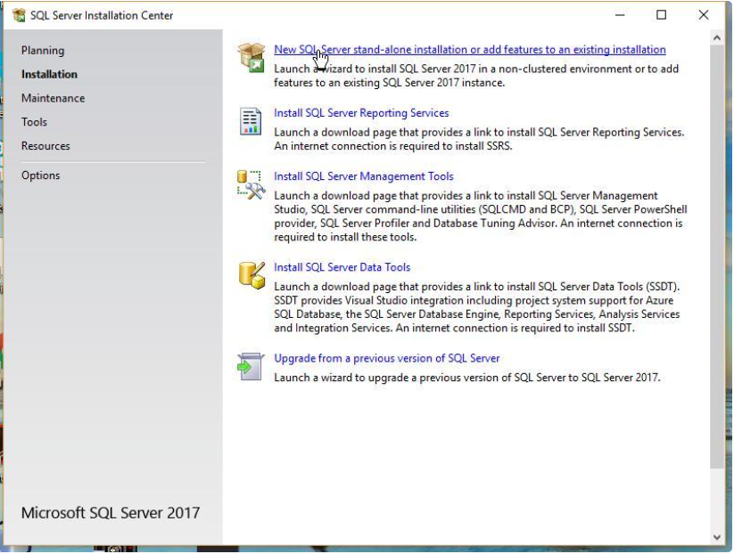

1. On the next screen, you’ll see a setup process. Once it completes, click Next.  
   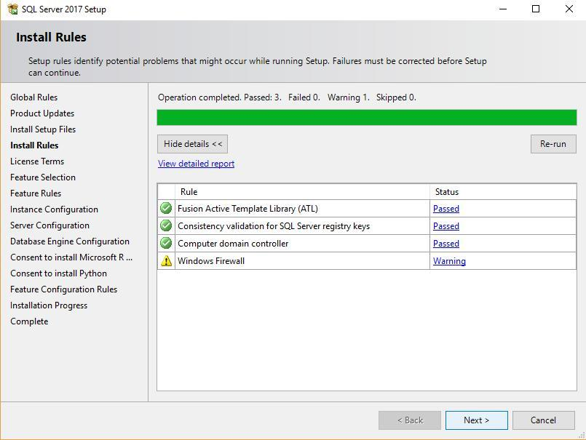
2. You should now see the license terms and click **Accept**. 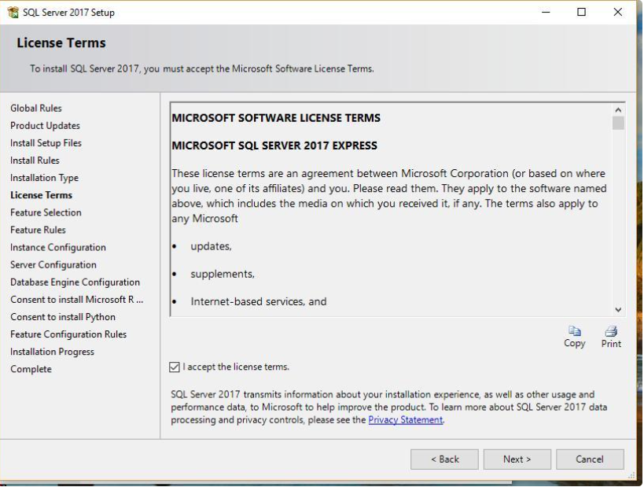
3. Select the feature selection:

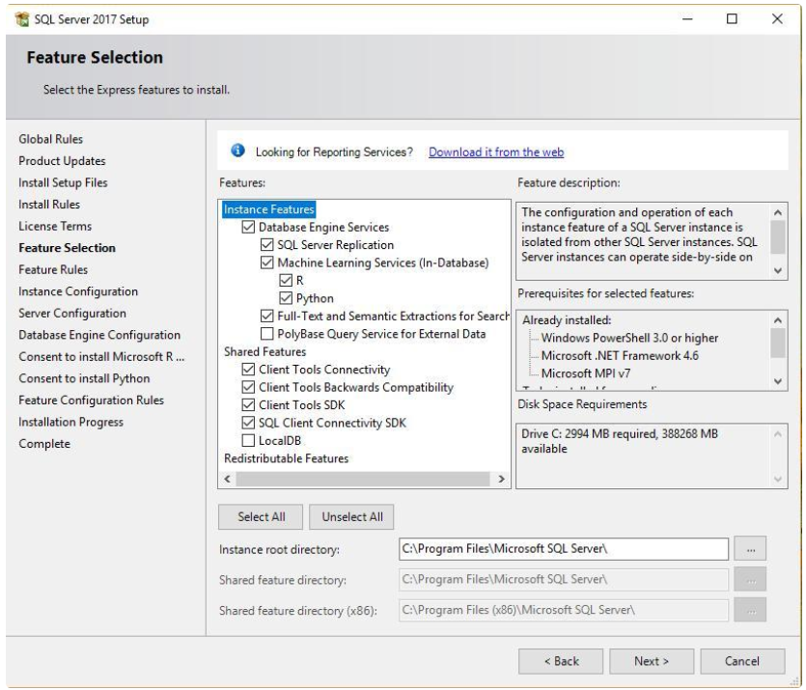

1. Select the default instance:

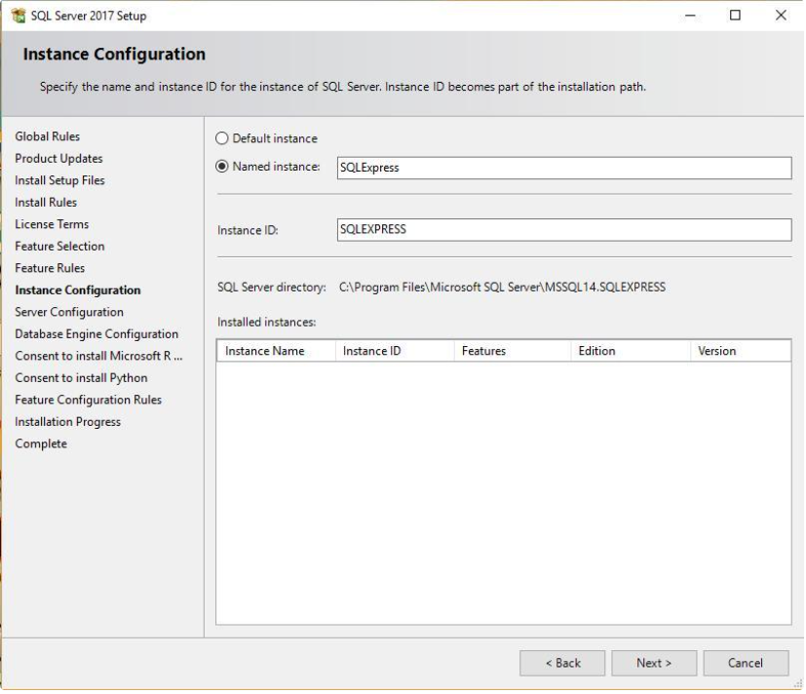

1. Click next and set configuration:

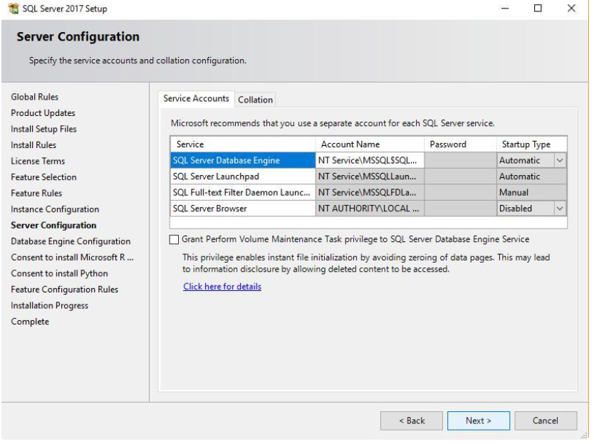

1. Select mixed authentication and database configuration and temp db configuration:

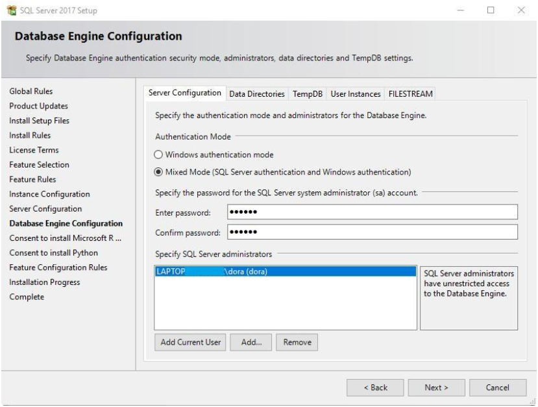

1. Click next and configuration summary:

